EXPERIMENT NO. 28

Pulling the Latest Changes from a GitHub Repository

Aim
To update a local Git repository by pulling the latest changes made by a collaborator from the remote GitHub repository.

Software Requirements
- Windows 10/11 (or Linux/macOS)
- Git
- GitHub Account
- Visual Studio Code (or any code editor)
- Web Browser
- Internet Connection

Theory
When multiple developers work on the same repository, changes made by one collaborator are uploaded to GitHub. Other collaborators use the git pull command to download and merge the latest changes into their local repository, ensuring everyone works with the most recent version of the project.

Procedure
Step 1: Clone the Repository
Open Git Bash or Terminal.
git clone https://github.com/YourUsername/RepositoryName.git

Move to the project folder.
cd RepositoryName

Step 2: Collaborator Makes Changes
- A collaborator opens the same repository.
- The collaborator modifies a file (for example, README.md).
- The collaborator stages, commits, and pushes the changes to GitHub.
Example commit message:
Updated README with project information

Step 3: Check the Current Status
Before pulling the latest changes, check the repository status.
git status

Step 4: Pull the Latest Changes
Download and merge the latest changes from the main branch.
git pull origin main

If the default branch is master, replace main with master.
Step 5: Verify the Changes
- Open the updated file (for example, README.md).
- Confirm that the collaborator's changes are present.
You can also check the commit history.
git log --oneline

Screenshots
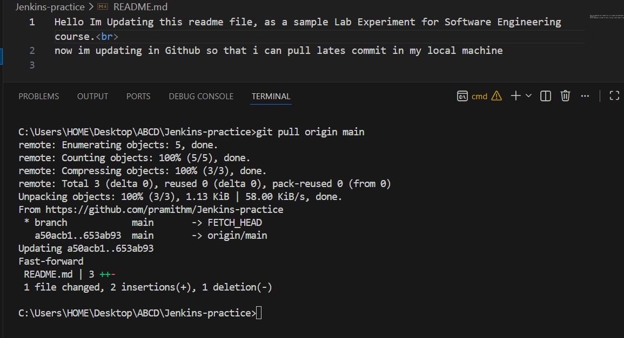

Observation
- The repository was cloned successfully.
- The collaborator pushed changes to GitHub.
- The latest changes were pulled successfully using git pull.
- The collaborator's updates appeared in the local repository.
- The local repository was synchronized with the remote repository.

Result
The latest changes made by the collaborator were successfully pulled from GitHub using the git pull command. The local repository was updated and synchronized with the remote repository.

